Recommendations

Colors in all visualizations except the first one reflects the following meaning: Dark shades are negative zones that need to be worked on, light shades are the success achieved in this area. In the first visualization, the colors reflect the different departments for easy differentiation between them.

This visualization clearly shows the direct relationship between care score and waiting time. The longer patients wait, the lower their score in the respective department. Therefore, it **is necessary to shorten the waiting time** to maximize the care score. The most significant efforts to reduce patient waiting times need to work in the Neurology and Nephrology departments, as they rank among the lowest among all departments.

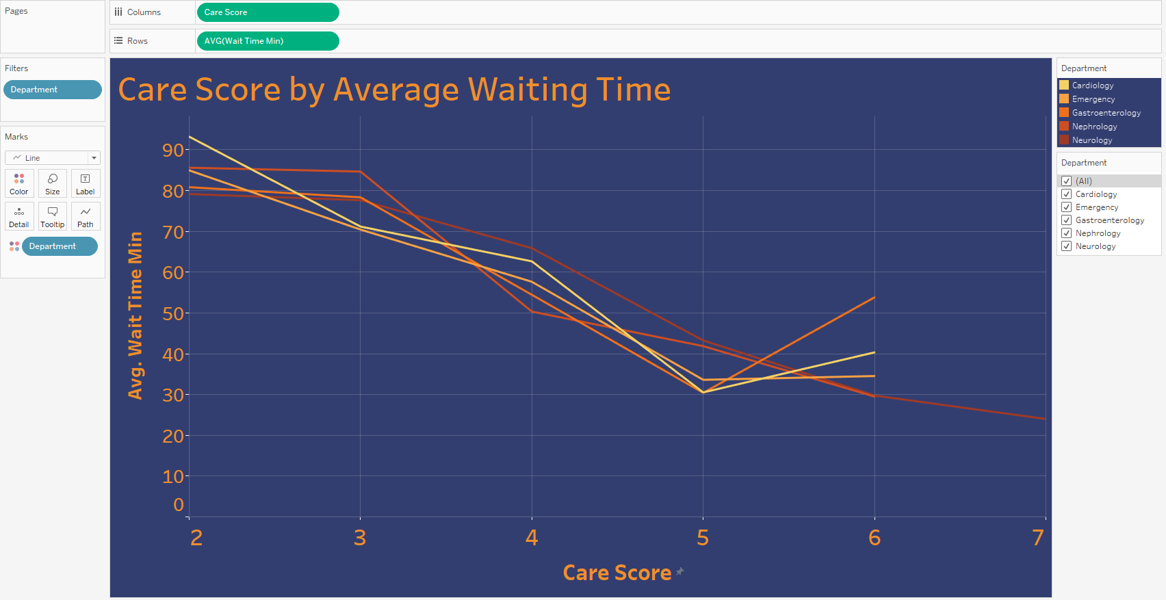

1) After analyzing the care score that patients left for different departments, we recommend **improving service quality for Gastroenterology, Neurology, and Nephrology** patients. These units have the lowest patient care ratings that come from a variety of sources.

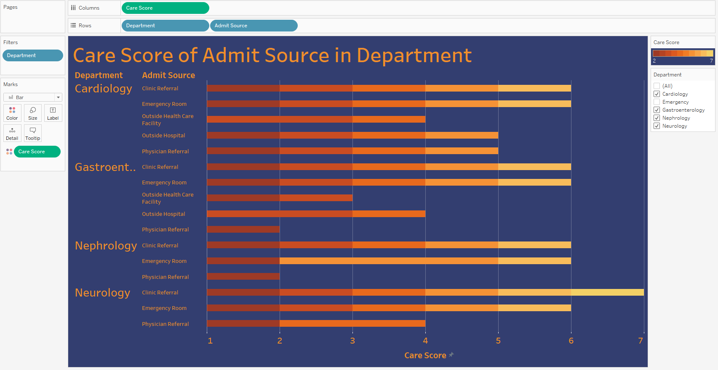

2) We also recommend **improving the quality** of services for patients upon admission. Because after **physical referral** of patients, the care rating is much lower than after other admit sources.

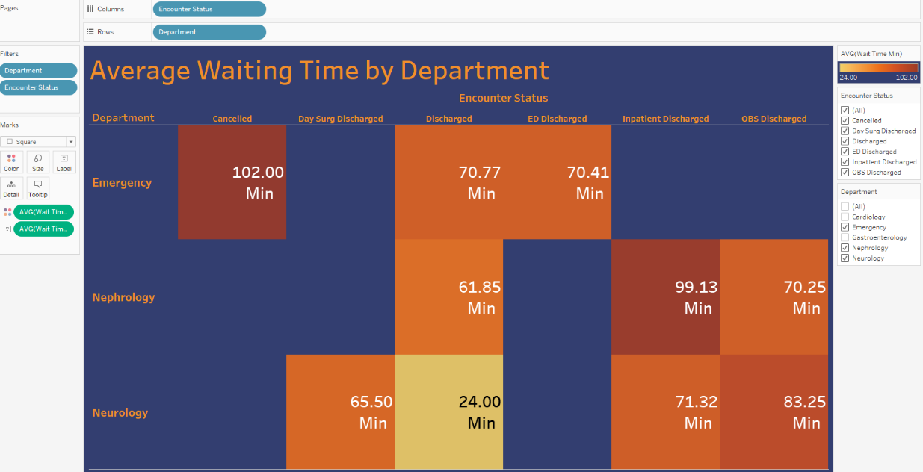

3) Based on the patient discharge data analysis, we also recommend **improving the quality of patient care at discharge**. Thus, if patients are satisfied with the department's quality of services, they will leave the best care score.

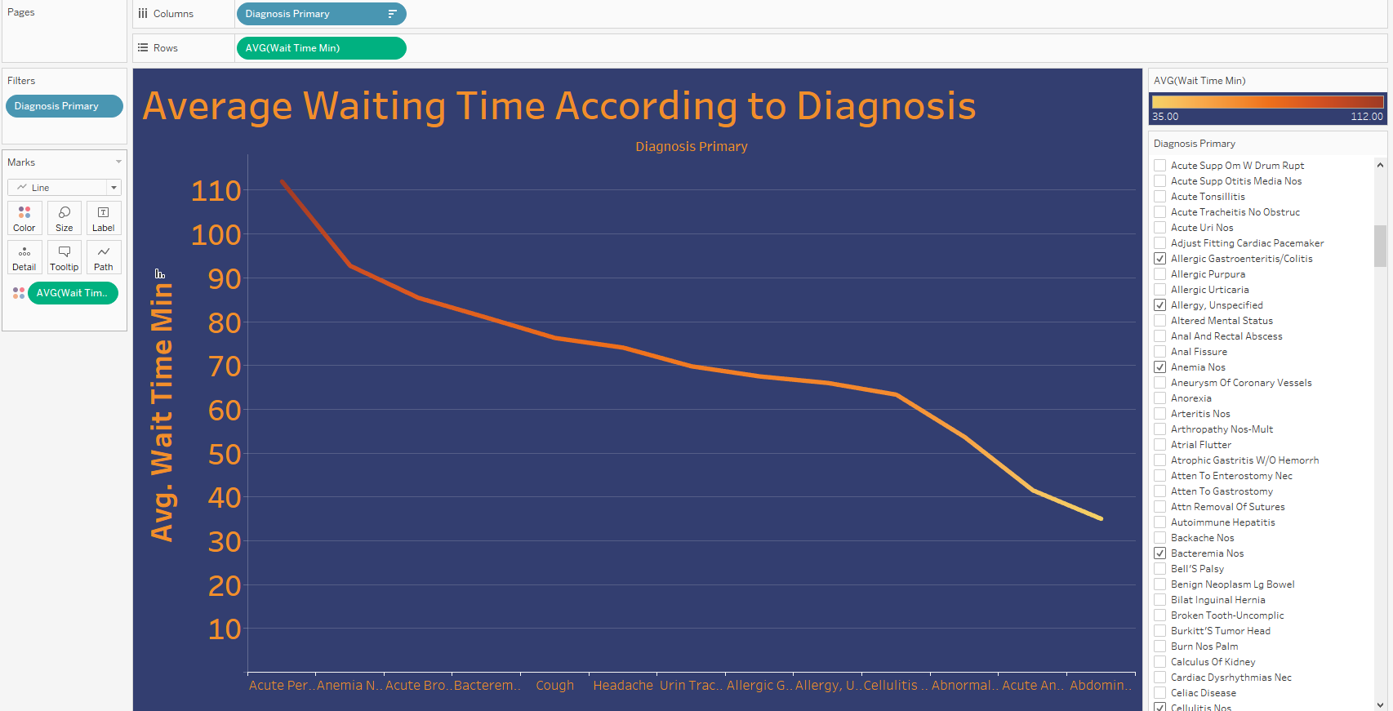

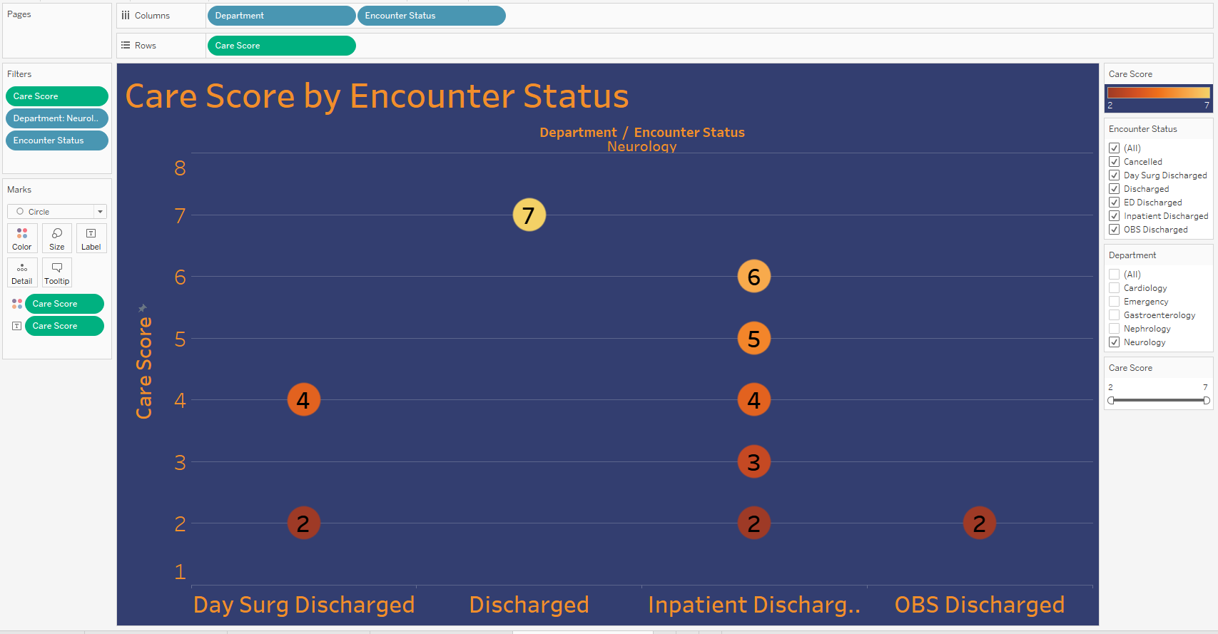

P.S. In the last two visualizations, we can see other examples of what the care score depends on. That is, based on the average time for diagnoses, it is possible to identify those diagnoses that take too much waiting time, and also based on the status of the discharge by department, it is possible to determine which departments need to be given special attention. These two visualizations are additional examples to the first three recommendations.